

**PROJECT REPORT**

**Virtual Classroom**

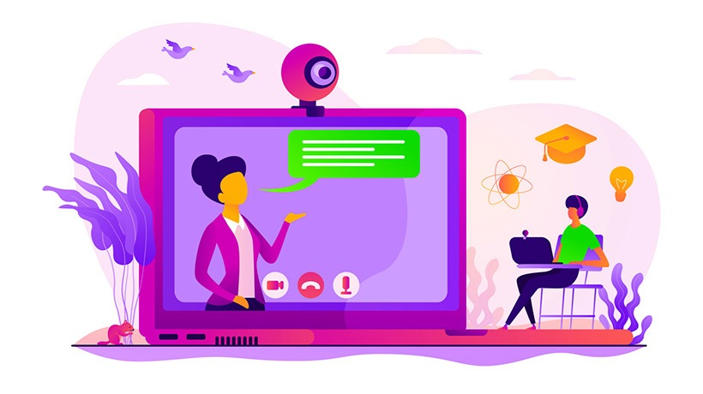

**CSE3001**

**Software Engineering (Theory)**

**J Component**

**Fall 2020-2021 Semester**

**Team Members:**

Wilson Vidyut,

Rishank Pratik,

Department of Computer Science and Engineering, Vellore Institute of Technology, Chennai Campus, Tamil Nadu, India.

**Acknowledgement**

We cannot express enough thanks and deep sense of gratitude to our project guide, Dr. Pradeep. K, Assistant Professor, School of Computer Science & Engineering, for his consistent encouragement and valuable guidance offered to us in a pleasant manner throughout the course of the project work.

We are extremely grateful to Dr. Jagadeesh Kannan, Dean of the School of Computer Science Engineering, VIT Chennai, for extending the facilities of the School towards our project and for his unstinting support.

We express our thanks to our Head of the Department Dr. Justus S for his support throughout the course of this project.

We also take this opportunity to thank all the faculty of the School for their support and their wisdom imparted to us throughout the course.

We thank our parents, family, and friends for bearing with us throughout the course of our project and for the opportunity they provided us in undergoing this course in such a prestigious institution.

Last, but not the least, we would like to thank Almighty for his love and support.

**Contents**

|  |  |
| --- | --- |
| **Title** | **Page No.** |
| **1. Abstract**  1.1 Statement of Problem  1.2 Limitations | **4**  4  4 |
| **2. Introduction**  2.1 Goal  2.2 Literature Survey | **5**  5  5 |
| **3. Software Requirement Specification**  3.1 Key Requirements  3.2 Functional Requirements  3.3 Non-Functional Requirements  3.4 Stakeholder Identification | **8**  8  8  9  10 |
| **4. Work Break Down Structure**  4.1 WBS by Phase  4.2 WBS by Product | **11**  11  11 |
| **5. Modelling and Analysis**  5.1 Process Model  5.2 System Modelling  5.2.1 Use Case Diagram  5.2.3 Class Diagram  5.2.6 Data Flow Diagrams | **12**  12  13  13  14  15 |
| **6. Proposed System**  6.1 Concept  6.2 List and description of modules  6.3 System Implementation (Sample Coding) | **16**  16  16  17 |
| **7. Testing**  7.1 Unit Testing  7.2 Integration Testing  7.3 System Testing  7.4 Acceptance Testing  7.5 Test Cases | **21**  21  22  22  22  23 |
| **8. Snapshots** | **26** |
| **9. Conclusion**  7.1 Future Scope  7.2 Future Work | **31**  31  31 |
| **10. References**  10.1 Citations | **32**  32 |

**Abstract**

**Statement of Problem**

During the current corona virus outbreak, it has become increasingly important to maintain social distancing and minimize contact. Covid-19 has brought the education system, particularly classroom teaching to a standstill, while the students in rural India were hit the maximum. Not every educational institution apart from well-established colleges and universities have access to online teaching portal. They still use methods like Video calling or chatting through WhatsApp. Popular applications like Google Meet and Zoom are designed to conduct meeting and not classes, hence they lack proper system for storage and access to study materials, quiz section.

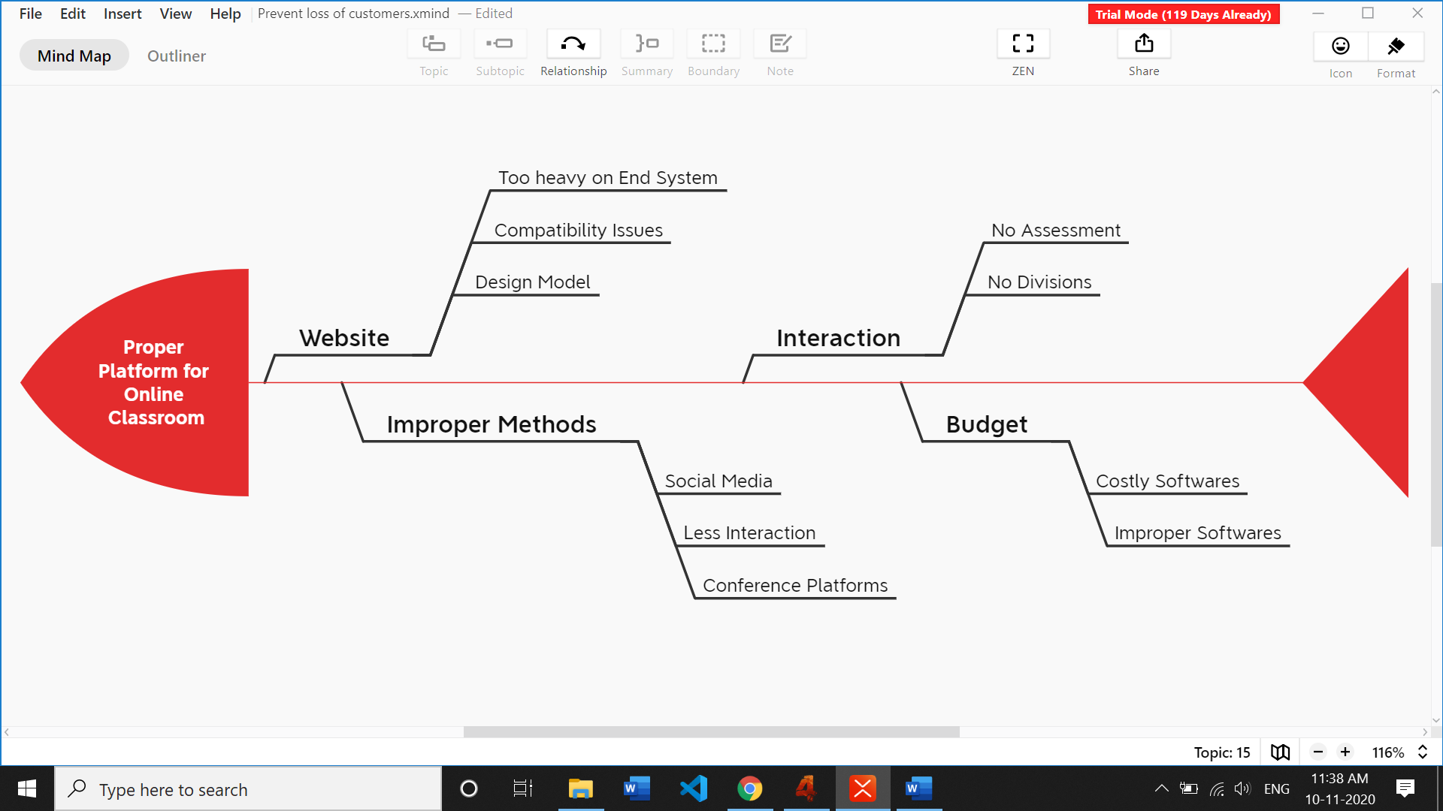

*A Fish-Bone diagram to visually represent causes of problem and sorting ideas into useful categories.*

**Limitations**

This application is inferior to modern meeting applications like Microsoft Teams and Google Classroom and should only be deployed where hardware and software specifications are low. The institution has to make provisions for the storage of data on server.

**Introduction**

A **virtual classroom** is a digital replica of a traditional classroom or training room. The instructors teach, interact, communicate, view and discuss presentations, and the participants learn in real-time, face-to-face but via internet-enabled technology devices.

Everything remains the way it is. The only difference is: an online classroom uses technology to support instruction and learning. What are the advantages of virtual classroom? It offers more flexibility over a traditional classroom. You can deliver the instruction to a geographically dispersed audience at one time.

**Goal**

With the advancement of technology, E-Learning is the future of education. Adding to that, the current Covid-19 has brought the education system, particularly classroom teaching to a standstill, while the students in rural India were hit the maximum. Not every educational institution apart from well-established colleges and universities have access to online teaching portal. They still use methods like Video calling or chatting through WhatsApp. Popular applications like Google Meet and Zoom are designed to conduct meeting and not classes, hence they lack proper system for storage and access to study materials, quiz section.

Hence, we aimed to design a simple, cost friendly and an efficient system to facilitate a classroom learning environment by improving makespan, cost and using limited yet proper resources.

**Literature Survey:**

1. **Reynolds, Kate, and Linda Flynn-Wilson. "Student perception of the quality of discussion in a synchronous virtual classroom environment." *EdMedia+ Innovate Learning*. Association for the Advancement of Computing in Education (AACE), 2018.**

* **Concept:** Observation feedback on interaction within a synchronous virtual classroom
* **Problems:** Analyzed why the format of the virtual classroom didn't encouraged robust discussion but didn’t provide solution.
* **How we fixed:** We made sure that our platform is user friendly and light on devices.

1. **Hofmann, Jennifer. "Solutions to the top 10 challenges of blended learning." *United states: InSync Training, LLC* (June 2020).**

* **Concept**: Use the best delivery methodology(ies) available for a specific objective, including online, classroom-based instruction, electronic performance support, paper-based, and formalized or informal on-the-job solutions.
* **Problems**: Explained the mutual understanding and coordination needed in new environment of education. But there is no mention of how-to asses student, to check if the methods are really working.
* **How we fixed**: We added assessments, assignments and result section to check student’s progress and level of understanding.

**Other Literature Survey:**

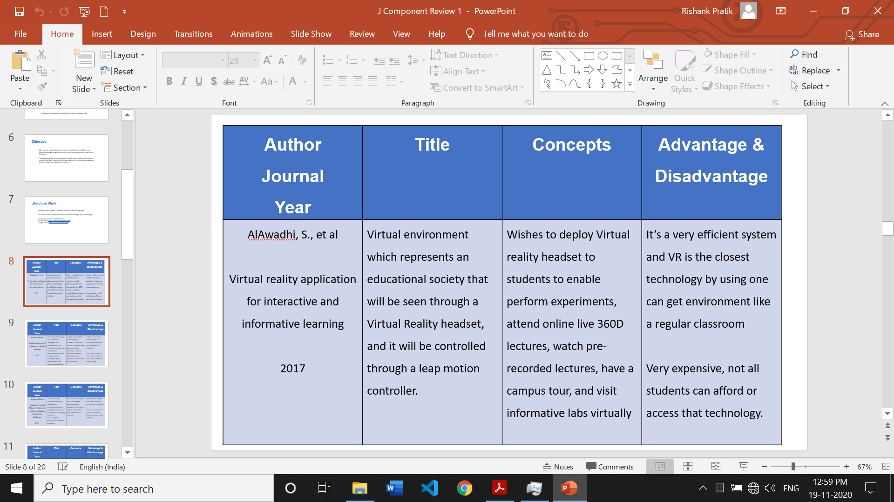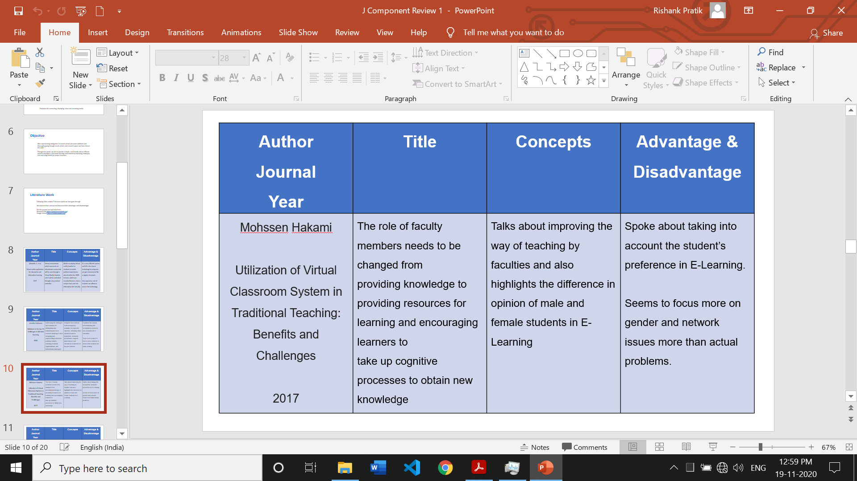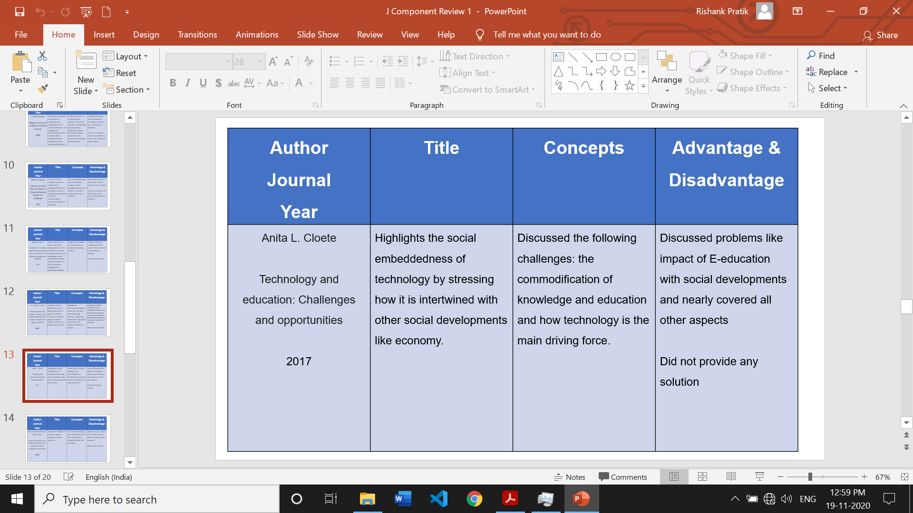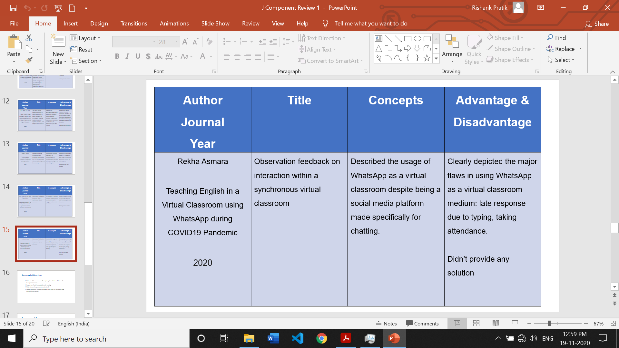

**Software Requirement Specification**

**Key Requirements and Constraints**

The project has to developed keeping in mind the minimum modules for an online classroom to function properly. For all those modules sufficient data has to gathered.

* **Power:** A group of two developers were required for development of this project.
* **Cost:** A computer system with modern hardware specifications was needed.
* **Time:** Three months were needed to develop this project.
* **Resources:** Basic knowledge of Full Stack Web Development such as LAMP was needed. In simple words, one must be proficient in HTML, CSS, JavaScript, PHP, NodeJS and SQL. One must also know how school or universities function in day to day life.

***Apart from this, the daily class report is to be made available to the faculty.***

**Functional Requirements**

* **Login/ SignUp:** A login screen for entering the username and password, so that the authorized user can have an access without any problem.
* **Department:** The Faculty will choose which department like Chemical, Electrical etc to address. Students don’t have option here as their departments are preallotted.
* **Subject:** This can be chosen by both student and faculty.
* **Materials:** Study materials in form on PDFs, Word files or video files can be uploaded by the teacher and viewed by students.
* **Students:** The students in class will have option to view other students in class while the teacher can view as well as mark the attendance of students.
* **Notices:** The teacher can send notices or circulars while students can view and respond to them.
* **Assessments:** Given by Faculty and taken by students.
* **Results:** Assessments are evaluated and displayed to students.

**Non-Functional Requirements**

**Performance requirements**

1. It is expected that the database would perform functionally all the requirements that are specified.

2. The system should be easy to handle.

3. System should give expected performance results.

4. The response time should be small.

**Security Requirements**

We need to develop a secured database. Only relevant authorities should view the data for eg: A student cannot view other student’s profile. There should not be any leakage of data. Make the database password protected and ensure proper standards of log in.

Depending upon the category of user the access rights are decided. It means if the user is an administrator then he can be able to modify the data, append etc. All other users only have the rights to retrieve the information about database.

**Safety Requirements**

The database may get crashed at any certain time due to virus or operating system failure. Therefore, it is required to take the database backup.

**Software Quality Attributes**

1. The application is easy to interact and communicate with user.

2. This application provides better user interface for ease of working.

**Design Constraints**

The web application, should work with Firefox, Internet Explorer 8, Google Chrome, Opera 10 and has to developed using HTML 5.

**Software Requirements**

The minimum software requirement is a Microsoft Windows 2000, Web Browser such as Google Chrome, Opera, Mozilla Firefox, Active Server Page (ASP), JAVA Script, HTML 5, Microsoft SQL Server 2000, Shockwave player and flash player.

**Hardware Requirements**

The hardware requirement consists of CPU Intel Pentium IIII 3.0 GHz or higher, memory (RAM) 1 GB or higher, Hard disk 80 GB or higher, Controller Support, Graphics Card, Network Interface Card. Monitor screen, mouse and a keyboard.

**Stakeholders Identification**

**1. Stakeholders:**

1. **Project Manager and Team:**   
   Responsible for managing the whole project. Project Manager is generally never involved in producing the end product but he/she controls, monitors and manages the activities involved in the production.
2. **Educational Institution:**  
   The Educational Institution is the one for which product is developed and will purchase the product.
3. **Administration:** They will govern the entire functioning of the application. They have the power to update or change anything in the database or application.
4. **Faculty:** They will facilitate learning.
5. **Student**: They will access learning.
6. **Parents:** They have to ensure that their child is properly able to access portal.

**2. Other Stakeholders:**

* 1. **Government:**

They are the ones who make the education policies. The educational institution has to act according to them.

**Work Break Down Structure**

**WBS by Phase**

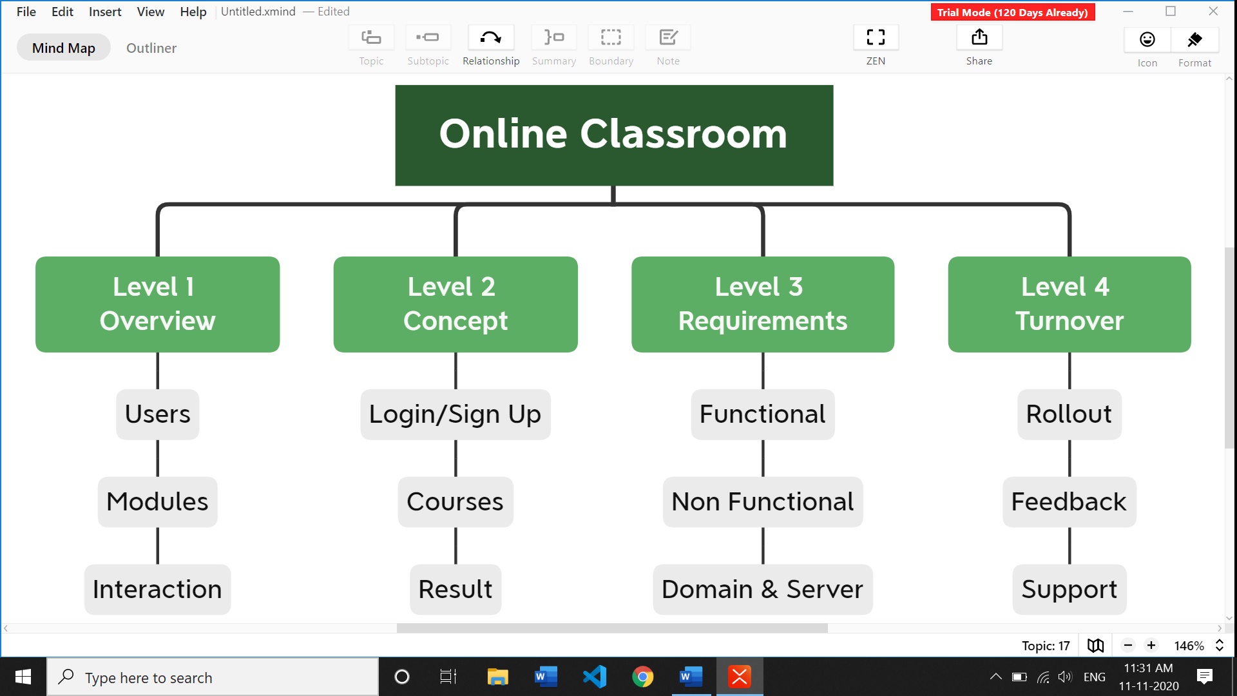

**WBS by Product**

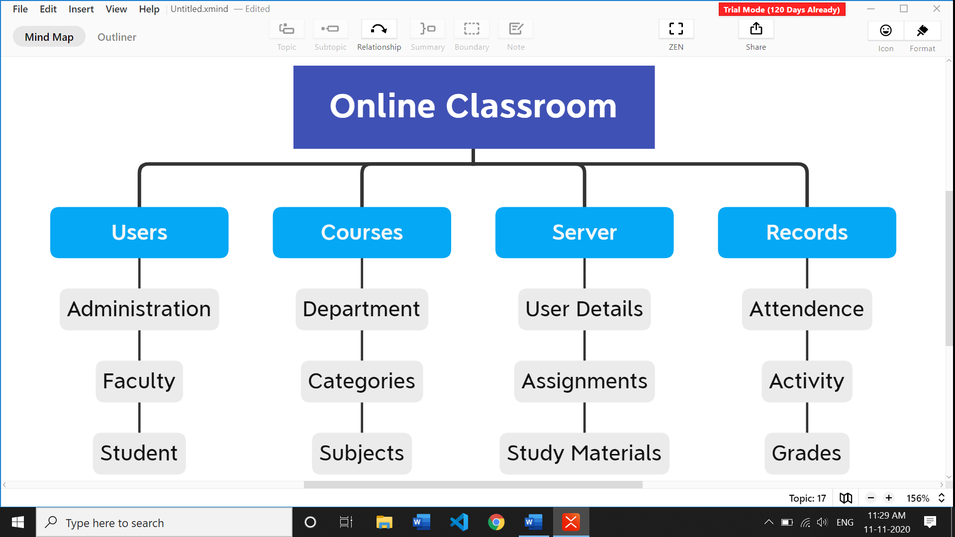

**Modelling & Analysis**

**Process Model**

**We have used Waterfall Model**. It’s useful when the requirements are clear, or following a very structured process as in critical systems which needs a detailed, precise, and accurate documents describes the system to be produced.

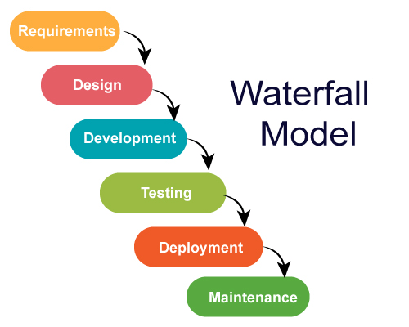

**We have used Waterfall Model because:**

* Our Requirements were very well documented, clear and fixed.
* Easy to manage due to the rigidity of the model. Each phase has specific deliverables and a review process.
* Well understood milestones.
* Product definition is stable.
* Technology is understood and is not dynamic.
* There are no ambiguous requirements.
* Phases are processed and completed one at a time.
* Process and results are well documented.

**System Modelling**

**Use Case Diagram**

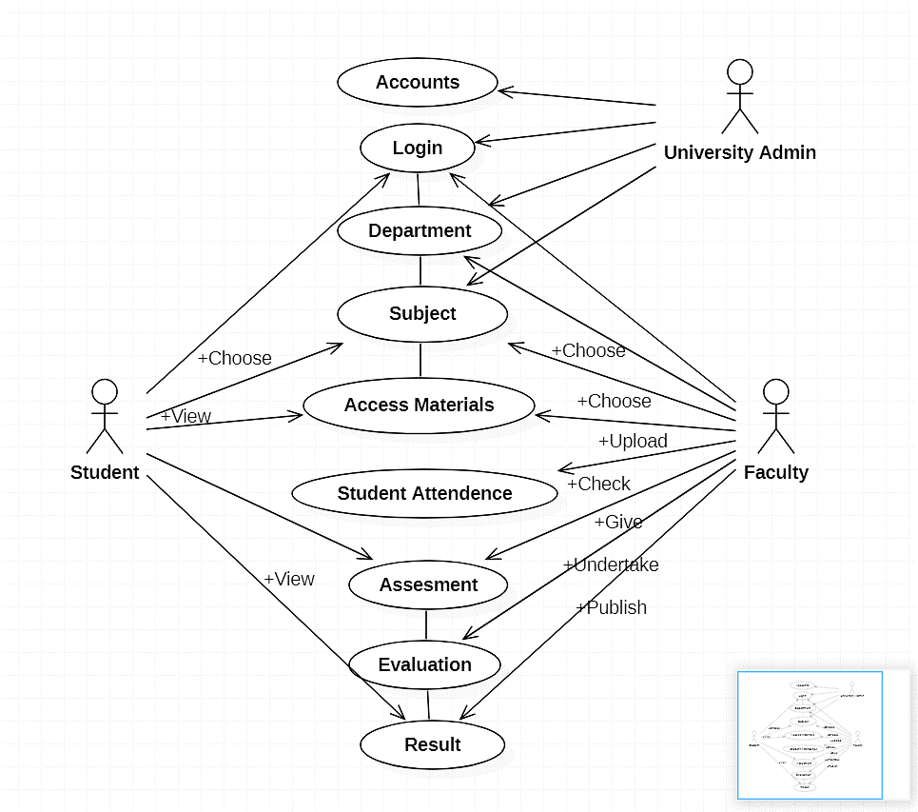

**Class Diagram**





**Data Flow Diagram (DFD)**

**DFD Level 0:**

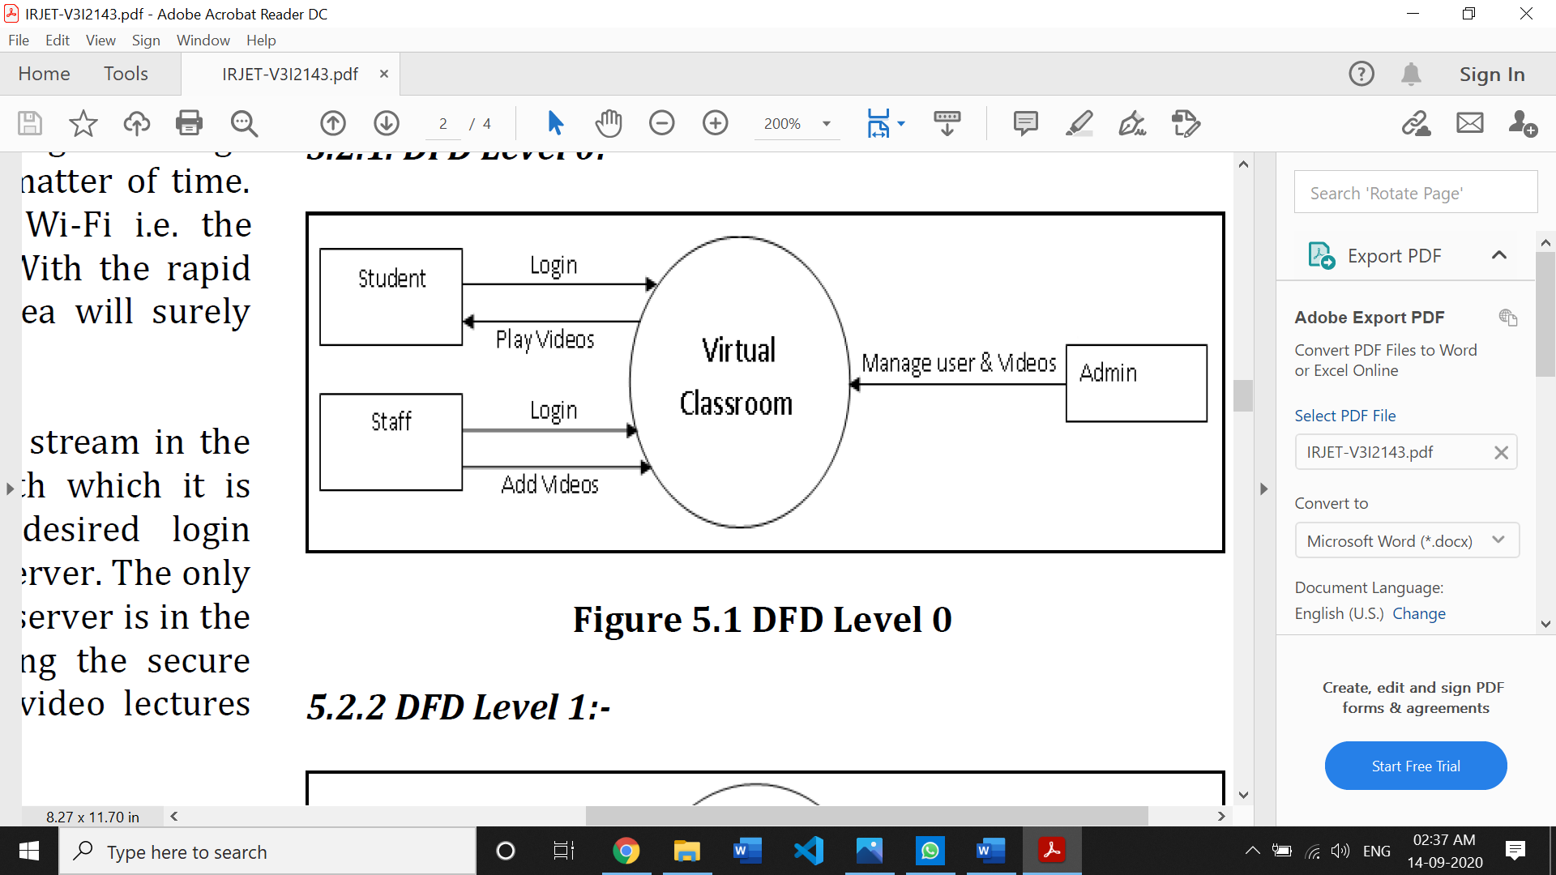

**DFD Level 1:**

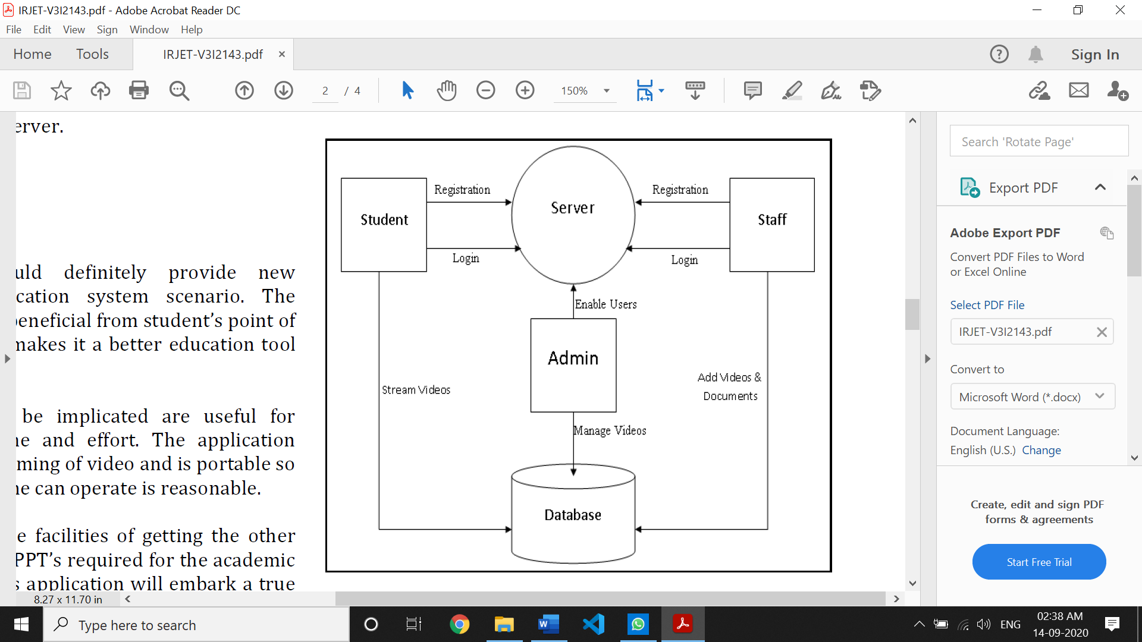

**DFD Level 2:**

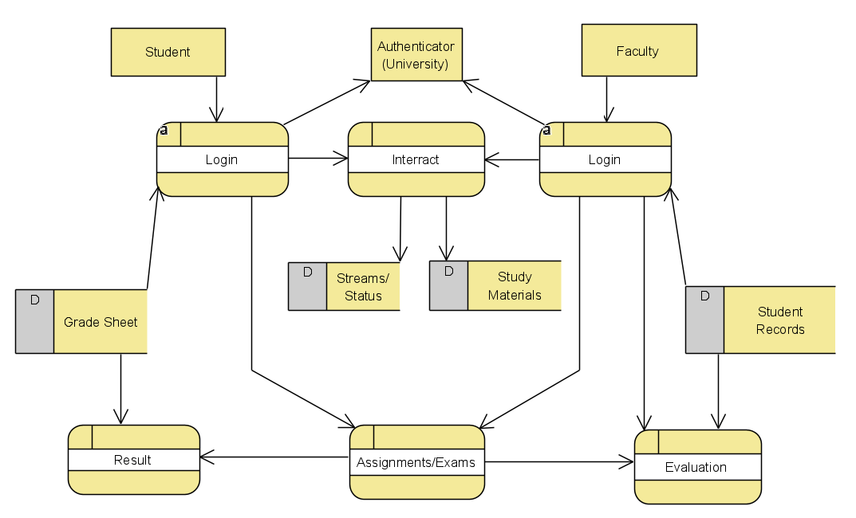

**Proposed System**

**Concept**

**List and description of modules**

Our project has the following modules:

1. **Login Page:** To facilitate login of faculty and students.
2. **Dashboard:** To get a brief overview of everything.
3. **Departments:** The faculty has option to choose the department. For example, a faculty belonging to Computer Science Department can also teach students belonging to AI/ML as well. This is accessible only by faculty and not by students.
4. **Categories:** The faculty also has option to select categories like Undergraduate, Post Graduate etc. Again, this is accessible only by faculty and not by students.
5. **Subjects:** The student as well as teachers can select subject of that particular department.
6. **Students:** Students in the class can be viewed through this section. Moreover, the faculty also has the power to take attendance by marking them.
7. **Examination:** Exams or Assessments are given by faculty. They can be either MCQs or descriptive. The students will take these and later on results will be declared in the result section.
8. **Results:** The results are calculated and displayed here along with statistics.
9. **Notices:** In this section, circulars are issued by faculty and viewed by student.

**System Implementation (Sample Coding)**

Index.php *(Main Page of Website)*

<!DOCTYPE html>

<?php include 'includes/check_reply.php'; ?>

<html>

<head>

        <title>OES | Login</title>

        <meta content="width=device-width, initial-scale=1" name="viewport"/>

        <meta charset="UTF-8">

        <meta name="description" content="Online Examination System" />

        <meta name="keywords" content="Online Examination System" />

        <meta name="author" content="Bwire Charles Mashauri" />

        <link href='http://fonts.googleapis.com/css?family=Open+Sans:400,300,600' rel='stylesheet' type='text/css'>

        <link href="assets/plugins/pace-master/themes/blue/pace-theme-flash.css" rel="stylesheet"/>

        <link href="assets/plugins/uniform/css/uniform.default.min.css" rel="stylesheet"/>

        <link href="assets/plugins/bootstrap/css/bootstrap.min.css" rel="stylesheet" type="text/css"/>

        <link href="assets/plugins/fontawesome/css/font-awesome.css" rel="stylesheet" type="text/css"/>

        <link href="assets/plugins/line-icons/simple-line-icons.css" rel="stylesheet" type="text/css"/>

        <link href="assets/plugins/offcanvasmenueffects/css/menu_cornerbox.css" rel="stylesheet" type="text/css"/>

        <link href="assets/plugins/waves/waves.min.css" rel="stylesheet" type="text/css"/>

        <link href="assets/plugins/switchery/switchery.min.css" rel="stylesheet" type="text/css"/>

        <link href="assets/plugins/3d-bold-navigation/css/style.css" rel="stylesheet" type="text/css"/>

        <link href="assets/images/icon.png" rel="icon">

        <link href="assets/css/modern.min.css" rel="stylesheet" type="text/css"/>

        <link href="assets/css/themes/green.css" class="theme-color" rel="stylesheet" type="text/css"/>

        <link href="assets/css/custom.css" rel="stylesheet" type="text/css"/>

         <link href="assets/css/snack.css" rel="stylesheet" type="text/css"/>

        <script src="assets/plugins/3d-bold-navigation/js/modernizr.js"></script>

        <script src="assets/plugins/offcanvasmenueffects/js/snap.svg-min.js"></script>

    </head>

     <body <?php if ($ms == "1") { print 'onload="myFunction()"'; } ?>  class="page-login">

        <main class="page-content">

            <div class="page-inner">

            <img src="kashipara.png" alt="" height="100" width="250">

                <div id="main-wrapper">

                    <div class="row">

                        <div class="col-md-4 center">

                            <div class="login-box">

                                <a href="./" class="logo-name text-lg text-center">Online Examination System</a>

                                <p class="text-center m-t-md">Please login into your account.</p>

                                <form class="m-t-md" action="pages/authentication.php" method="POST">

                                    <div class="form-group">

                                        <input type="text" class="form-control" placeholder="Email or Registration No."  autocomplete="off" name="user" required>

                                    </div>

                                    <div class="form-group">

                                        <input type="password" class="form-control" placeholder="Your strong password" name="login" required>

                                    </div>

                                    <button type="submit" class="btn btn-success btn-block">Login</button>

                                    <a href="forgot_pw.php" class="display-block text-center m-t-md text-sm">Forgot Password?</a>

                                </form>

                            </div>

                        </div>

                    </div>

                </div>

            </div>

        </main>

            <?php if ($ms == "1") {

?> <div class="alert alert-success" id="snackbar"><?php echo "$description"; ?></div> <?php

}else{

}

?>

        <script src="assets/plugins/jquery/jquery-2.1.4.min.js"></script>

        <script src="assets/plugins/jquery-ui/jquery-ui.min.js"></script>

        <script src="assets/plugins/pace-master/pace.min.js"></script>

        <script src="assets/plugins/jquery-blockui/jquery.blockui.js"></script>

        <script src="assets/plugins/bootstrap/js/bootstrap.min.js"></script>

        <script src="assets/plugins/jquery-slimscroll/jquery.slimscroll.min.js"></script>

        <script src="assets/plugins/switchery/switchery.min.js"></script>

        <script src="assets/plugins/uniform/jquery.uniform.min.js"></script>

        <script src="assets/plugins/offcanvasmenueffects/js/classie.js"></script>

        <script src="assets/plugins/waves/waves.min.js"></script>

        <script src="assets/js/modern.min.js"></script>

                <script>

function myFunction() {

    var x = document.getElementById("snackbar")

    x.className = "show";

    setTimeout(function(){ x.className = x.className.replace("show", ""); }, 3000);

}

</script>

    </body>

</html>

Submit_assessment.php *(Assessments Page of Website)*

<?php

error_reporting(0);

$total_questions = $_POST['tq'];

$starting_mark = 1;

$mytotal_marks = 0;

$exam_id = $_POST['eid'];

$record = $_POST['ri'];

while ($starting_mark <= $total_questions) {

if (strtoupper(base64_decode($_POST['ran'.$starting_mark.''])) == strtoupper($_POST['an'.$starting_mark.''])) {

$mytotal_marks = $mytotal_marks + 1;

}else{

}

$starting_mark++;

}

$percent_score = ($mytotal_marks / $total_questions) * 100;

$percent_score = floor($percent_score);

$passmark = $_POST['pm'];

if ($percent_score >= $passmark) {

$status = "PASS";

}else{

$status = "FAIL";

}

session_start();

$_SESSION['record_id'] = $record;

include '../../database/config.php';

$sql = "UPDATE tbl_assessment_records SET score='$percent_score', status='$status' WHERE record_id='$record'";

if ($conn->query($sql) === TRUE) {

   header("location:../assessment-info.php");

} else {

   header("location:../assessment-info.php");

}

$conn->close();

?>

Rest of the coding is posted in my GitHub Repository: <https://github.com/RishankPratik/Software-Engg-Project>

**Testing**

**Unit Testing**

It is a type of software testing where individual units or components of a software are tested.

**1) Unit Testing of button function**: Interactive Buttons along with JavaScript code in our webpage play a vital role website functioning. It is because of them that we are able to move from one page/section to other.

<body <?php if ($ms == "1") { print 'onload="myFunction()"'; } ?>

//Code

<button class="close-button" id="close-button">Close Menu</button>

function myFunction() {

    var x = document.getElementById("snackbar")

    x.className = "show";

    setTimeout(function(){ x.className = x.className.replace("show", ""); }, 3000);

As we can see code is correct and the button works fine.

**2) Unit Testing of database connection**: Any data is very sensitive and important. It must be ensured that proper connection to Database had been made and that the data is fetched properly and securely.

<?php

error_reporting(0);

$servername = "localhost";

$username = "root";

$password = "";

$dbname = "online";

$conn = new mysqli($servername, $username, $password, $dbname);

if ($conn->connect_error) {

die("<h2>Database Connection Failure : " . $conn->connect_error . "</h2><hr>");

}

?>

The database connection works fine and all the details and information are displayed correctly.

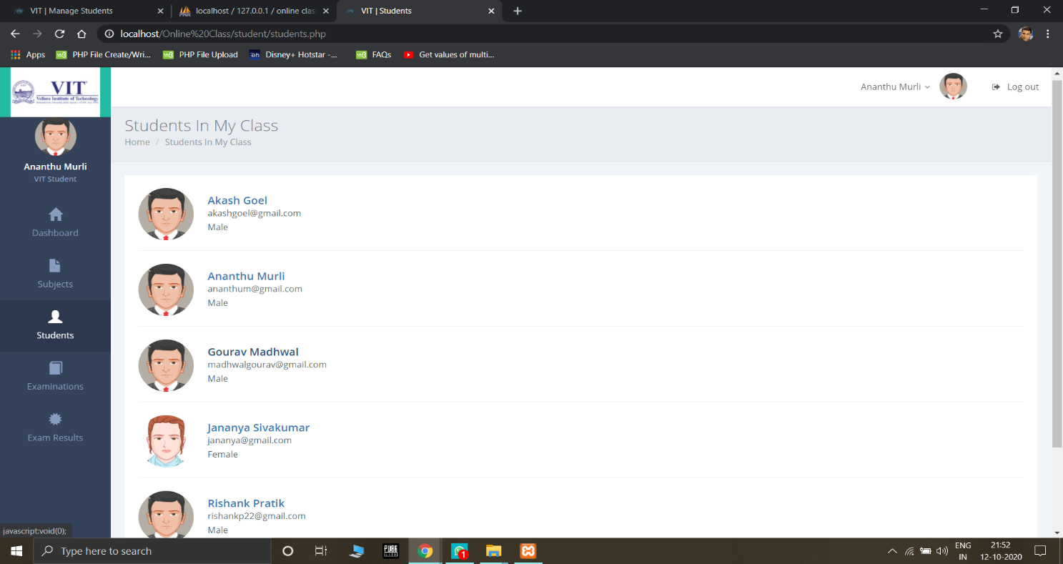

**Integration Testing**

It is defined as a type of testing where software modules are integrated logically and tested as a group.

Here modules can be tabs on the vertical nav bar

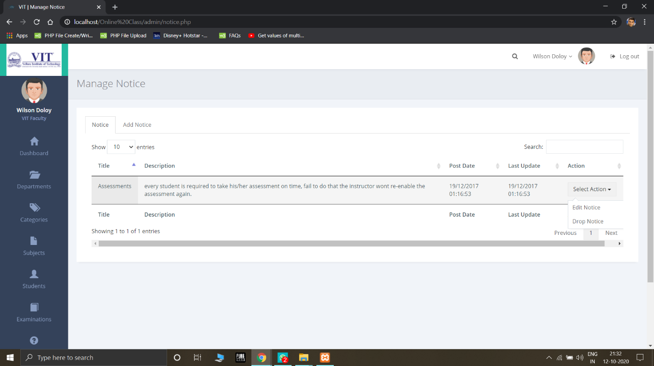<div class="panel info-box panel-white">

 <div class="panel-body">

   <div class="info-box-stats">

     <p><span class="counter"><?php echo number_format($examination); ?></span></p>

        <span class="info-box-title">EXAMINATIONS</span>

   </div>

<div class="info-box-icon">

      <i class="icon-book-open"></i>

   </div>

 </div>

</div>

Here modules are working fine as the desired output is achieved

**System Testing**

It is a level of testing that validates the complete and fully integrated software product.

Our product is working perfectly and the user is able to switch between tabs and perform required function. Hence, we can say our product has passed the System Testing.

**Acceptance Testing**

This is a type of testing done by users, customers, or other authorised entities to determine application/software needs and business processes.

This software was made especially for the educational institutions keeping in mind all the required functionalities for day to day running of Online Education. It has met their requirements.

**Test Cases**

|  |  |  |  |  |  |  |
| --- | --- | --- | --- | --- | --- | --- |
| **Number TS1** | | | | | |  |
| **Title** | | Verify “Login” functionality | | | |  |
| **Description** | | To test the different scenarios that might arise while a user is trying to login | | | |  |
| **Number Summary** | | | **Pre-condition Post-condition Execution Steps** | | | **Expected Output** |
| **TC1** | The Login is successful | | The user enters all the details for Login correctly | The user will get notified that the Login is successful | Entering in the details provided in the Login page | Login  Successful |
| **TC2** | The Login is not successful | | The user enters one incorrect detail in the page | The user will get notified that the login was declined | Entering in the details provided in the Login page | Login Failed. Please Retry |

|  |  |  |  |  |  |  |
| --- | --- | --- | --- | --- | --- | --- |
| **Number TS2** | | | | | | |
| **Title** | | Verify “Result” functionality | | | | |
| **Description** | | To test the different scenarios that might arise when student gives and check result of an examination. | | | | |
| **Number Summary Pre-condition Post-condition Execution Steps Expected**  **Output** | | | | | | |
| **TC1** | The Result is passed and correct | | The student answered everything correctly | The user will get notified that the he’s passed | Answering in the  Assessment Section | Pass |
| **TC2** | The Result is failed and correct | | The student failed to answer everything correctly | The user will get notified that the he’s failed | Answering in the  Assessment Section | Fail |
| **TC3** | The Result is passed and incorrect | | The student wrote both wrong and correct in the same answer | The user will get notified that the he’ll get half the marks of that question and to check with the faculty | Answering in the  Assessment  Section | Pass |
| **TC4** | The Result is failed and incorrect | | The student’s answer was correct but alphabet cases/ grammar didn’t match | The user will get notified that the he’ll get half the marks of that question and to check with the faculty | Answering in the  Assessment  Section | Fail |

|  |  |  |  |  |  |  |
| --- | --- | --- | --- | --- | --- | --- |
| **Number TS3** | | | | | | |
| **Title** | | Verify “Registration” functionality | | | | |
| **Description** | | To test registration of a new user. | | | | |
| **Number Summary Pre-condition Post-condition Execution Steps Expected**  **Output** | | | | | | |
| **TC1** | Registration Successful | | The student has put a correct email address | The student will get password in his email | Put email address | Registration Successful |
| **TC2** | Registration Unsuccessful | | The student has put a correct email address | The student did not get password in his email | Put email address | Registration Unsuccessful |
| **TC3** | Registration Unsuccessful | | The student has put an incorrect email address | The student did not get password in his email | Put email address | Registration Unsuccessful |

|  |  |  |  |  |  |  |  |  |  |
| --- | --- | --- | --- | --- | --- | --- | --- | --- | --- |
| **Number TS4** | | | | | | | | | |
| **Title** | | Verify “Attendance” functionality | | | | | | | |
| **Description** | | To test attendance function | | | | | | | |
| **Number Summary Pre-condition Post-condition Execution Steps Expected**  **Output** | | | | | | | | | |
| **TC1** | The attendance is marked as Present | | The student attended class and assessments | | The attendance is marked as Present | | | Attend class, assessments and be interactive. | Present |
| **TC2** | The attendance is marked as Absent | | The student attended class and assessments but remained idle | | The attendance is marked as Absent | | | Attend class and assessments | Absent |
| **TC3** | The attendance is marked as Absent | | The student attended class but didn’t do assessments | | The attendance is marked as Absent | | | Attend class | Absent |
| **TC4** | The attendance is marked as Absent | | The student didn’t attend class | | The attendance is marked as Absent | | | Don’t attend class | Absent |
| **Number TS5** | | | | | | | | |  |
| **Title** | | Verify “Status” functionality in Departments, Categories, Subjects | | | | | | |  |
| **Description** | | To test the working of Status button | | | | | | |  |
| **Number Summary** | | | | **Pre-condition Post-condition Execution Steps** | | | | | **Expected Output** |
| **TC1** | The Status is Active | | | The Status must be Inactive | | The Status is Active | Set Status as Active | | ACTIVE |
| **TC2** | The Status is Inactive | | | The Status must be Active | | The Status is Inactive | Set Status as Inactive | | INACTIVE |

|  |  |  |  |  |  |  |
| --- | --- | --- | --- | --- | --- | --- |
| **Number TS6** | | | | | |  |
| **Title** | | Verify “Pie Chart” functionality | | | |  |
| **Description** | | To test the Pie Chart graph validity | | | |  |
| **Number Summary** | | | **Pre-condition Post-condition Execution Steps** | | | **Expected Output** |
| **TC1** | The Graph is correct | | Data is sufficient and correct | Graph is displayed correctly | Database commands are correctly executed | A correct Pie Chart |
| **TC2** | The Graph is incorrect | | Data is insufficient or corrupted | Graph is not correct or not displayed | Database commands are incorrectly executed or data has been corrupted | An incorrect Pie Chart |

|  |  |  |  |  |  |  |
| --- | --- | --- | --- | --- | --- | --- |
| **Number TS7** | | | | | |  |
| **Title** | | Verify “Logout” functionality | | | |  |
| **Description** | | To test the logout function | | | |  |
| **Number Summary** | | | **Pre-condition Post-condition Execution Steps** | | | **Expected Output** |
| **TC1** | The Logout is successful | | The user should have logged in | The Logout is successful | Click on Logout | Logout  Successful |
| **TC2** | The Logout is not successful | | The user should not have logged in or bad internet connection | The Logout is not successful | Click on Logout | Logout Failed |

**Snapshots**

***Main Page***

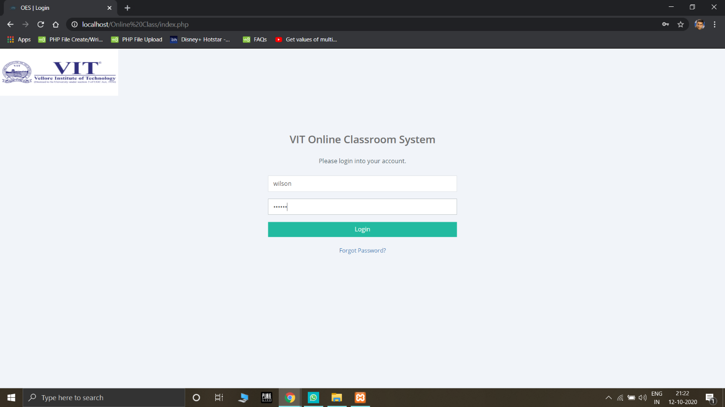

***Student Dashboard Page***

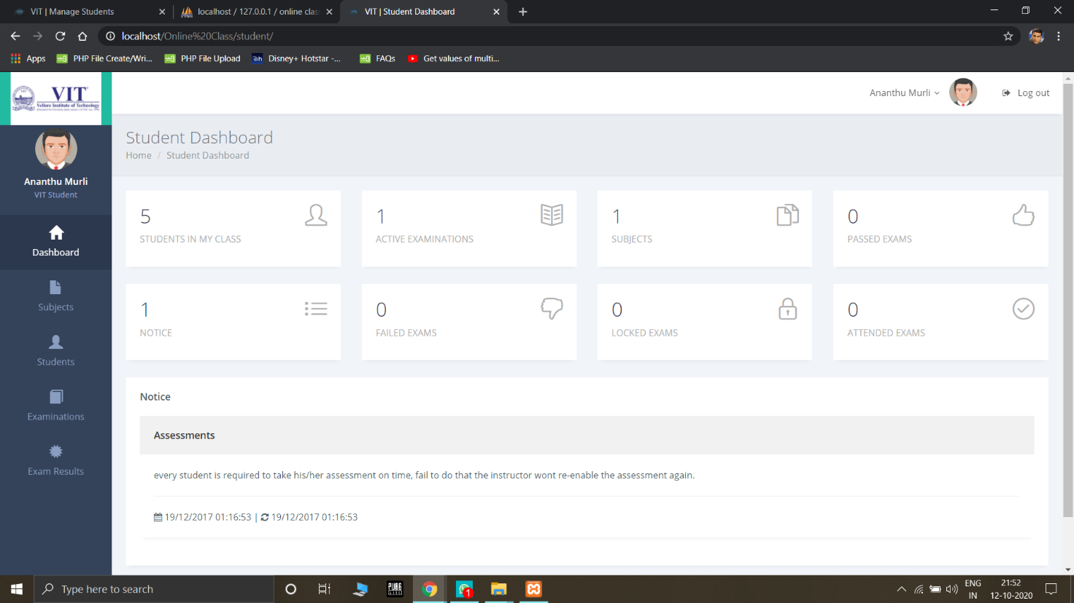

***Faculty Dashboard Page***

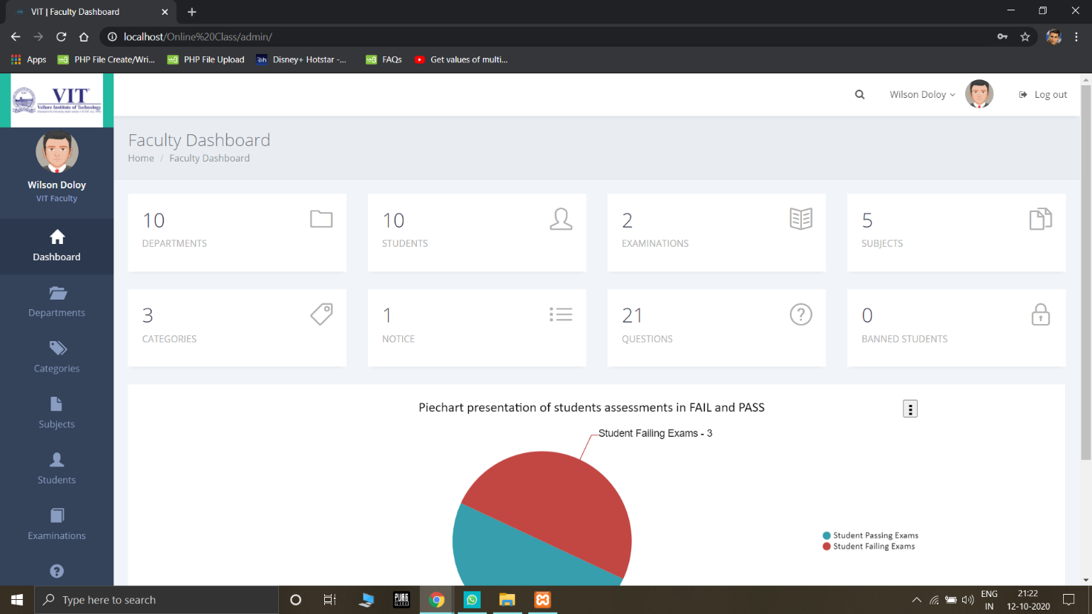

***Departments Page***

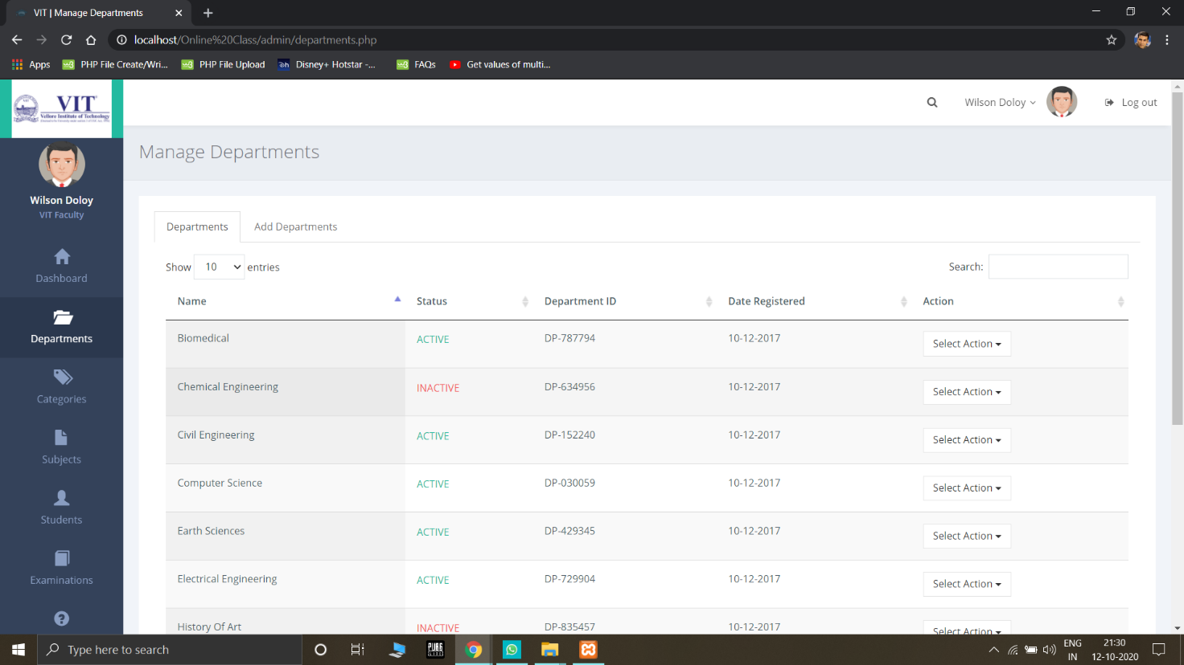

***Subjects Page***

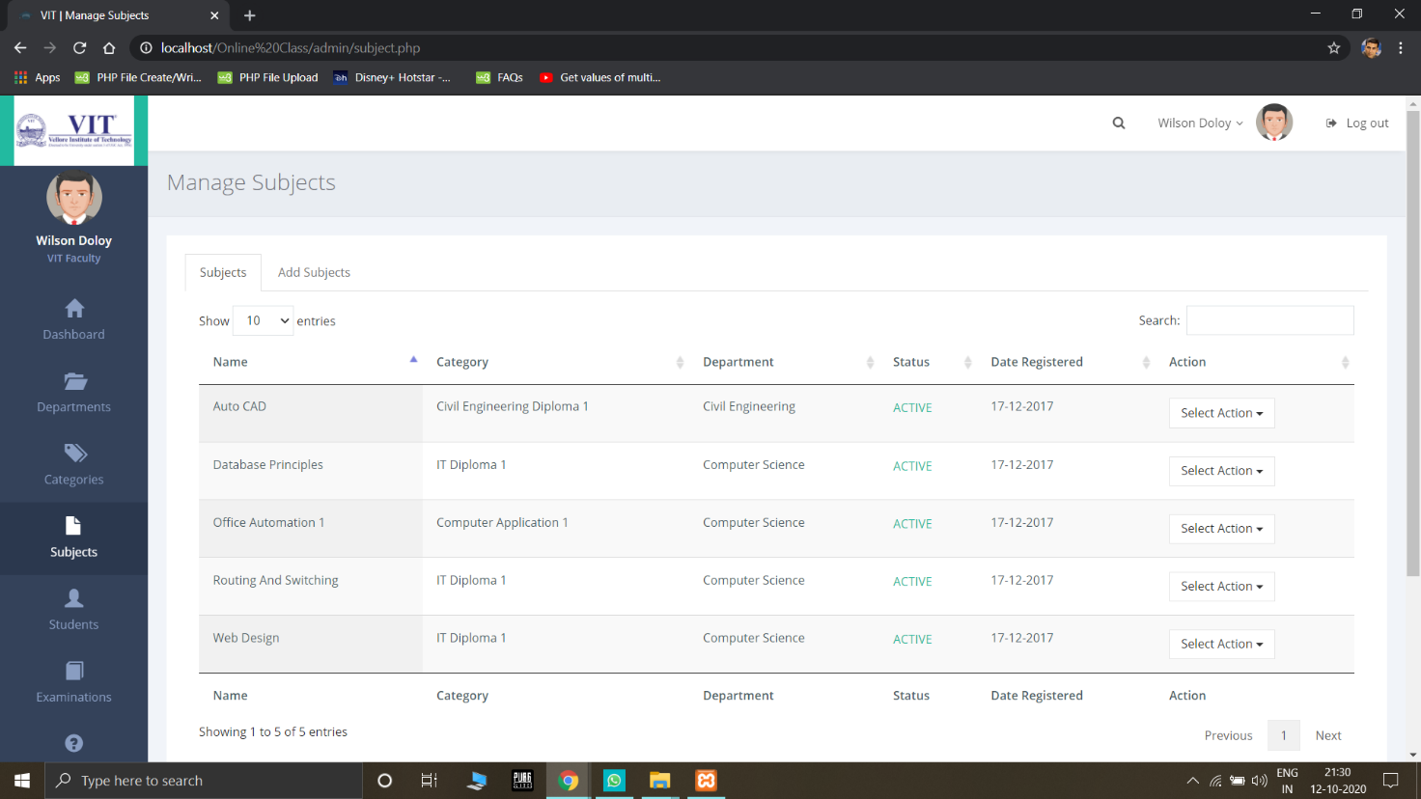

***Students Page***

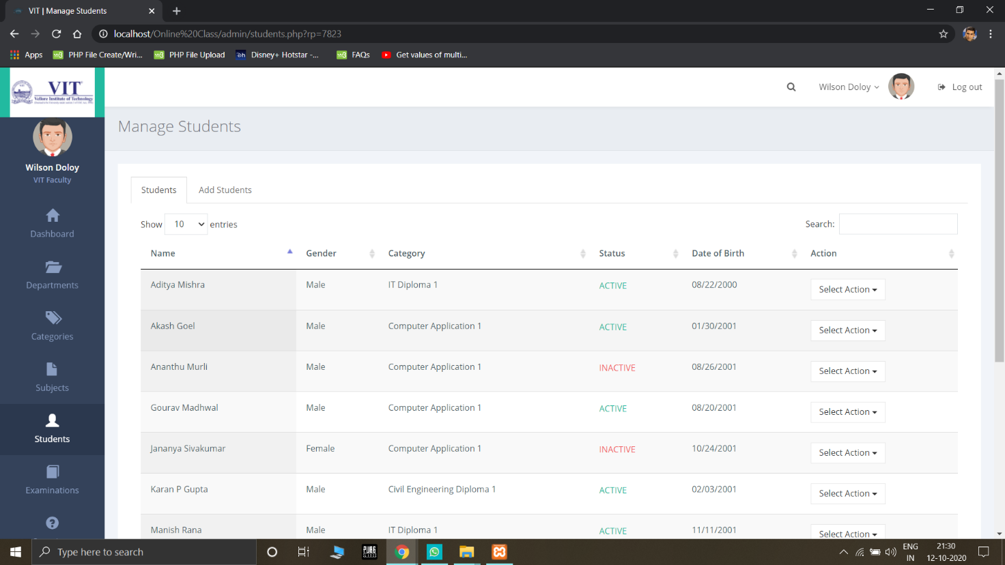

***Add Questions Page***

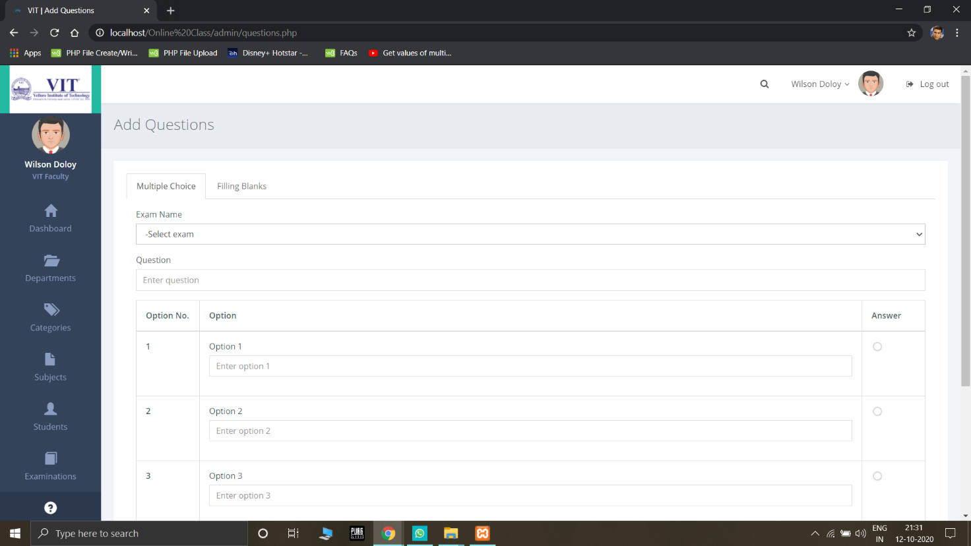

***Examination Page***

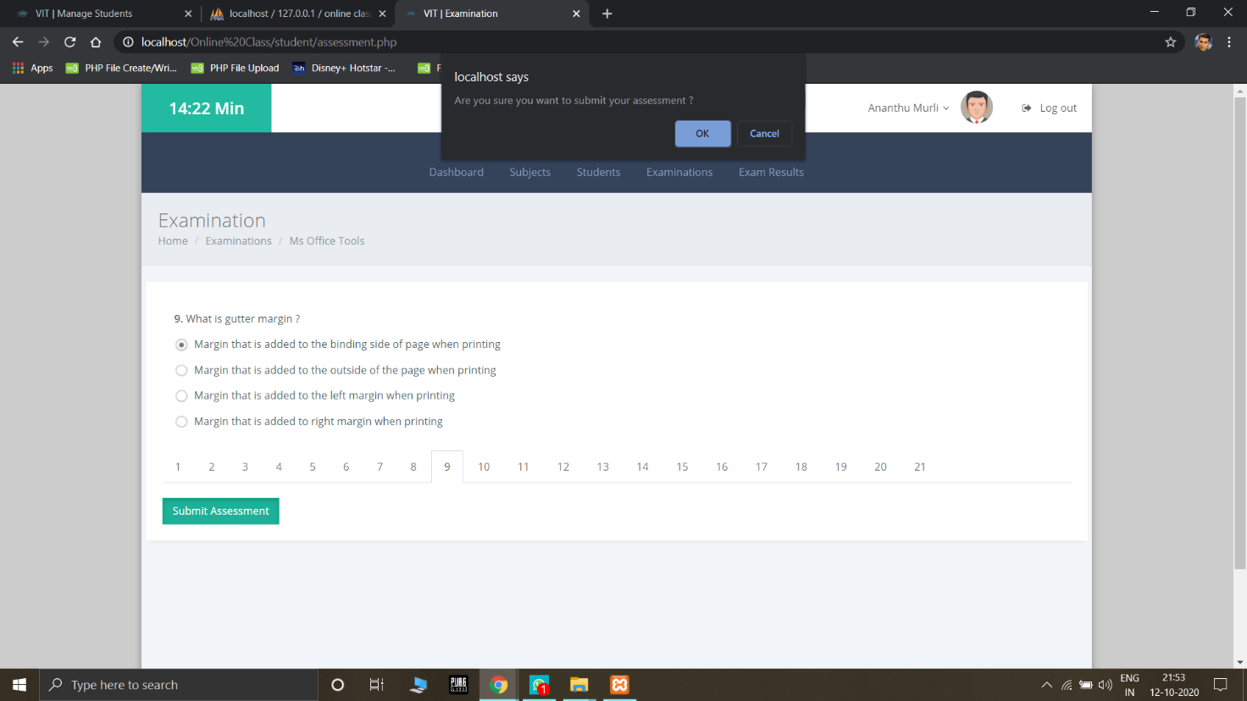

***Assessments Page***

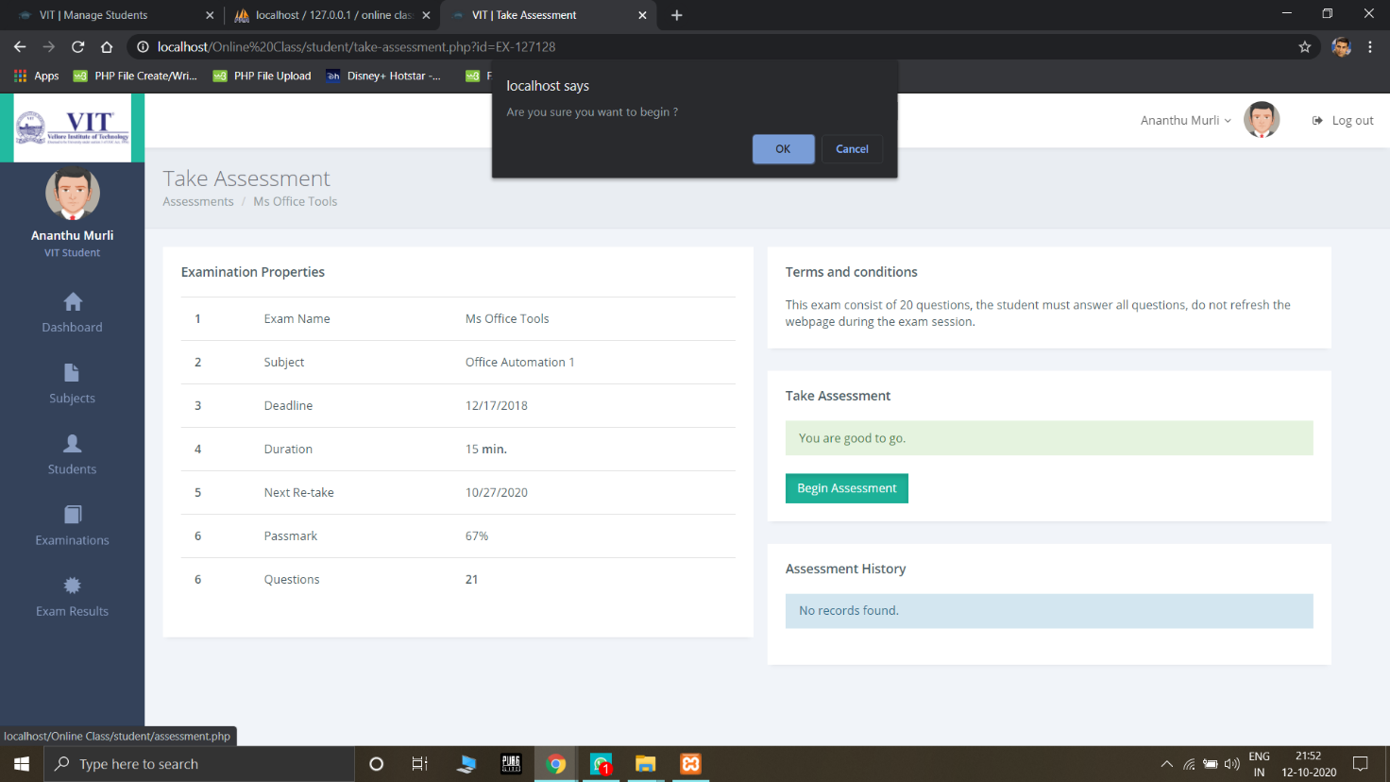

***Notices Page***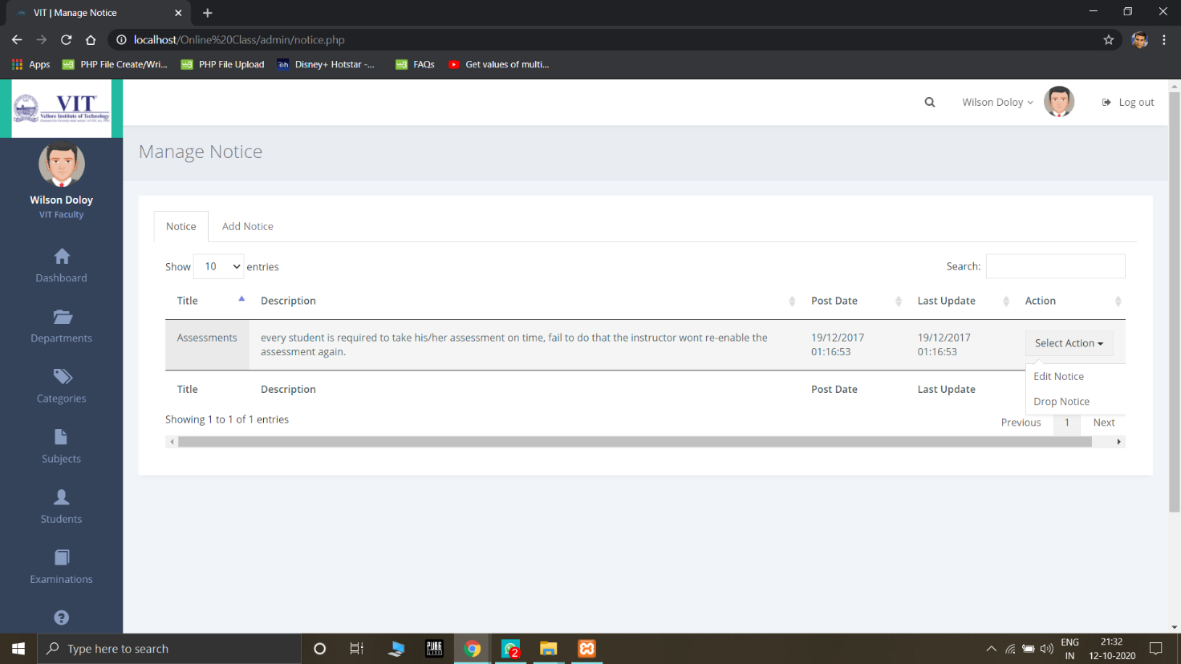

**Conclusion**

Through our work, we have emphasised on making a much needed, perfect overall application which has all the needed systems for proper functioning of an educational institution. We mainly paid attention to students belonging to rural society so that they are benefited with this project. Along with it we have focused on:

* Make virtual classroom an overall complete system which has all features like in a regular classroom.
* Despise use of social media platforms for teaching.
* Make software cheap, lightweight and easy to understand.
* Allow an application, simulation or drawing board inside the software to make practical classes possible.

**Future Scope**

This product definitely has a lot of scope in future. With the advent of technology and current corona virus scenario it has become increasingly important to adopt online teaching through efficient platforms.

**Future Work**

We aim to add the Video Streaming option in it to enable the faculty and students interact through video mode. We also aim to add a white board function.

**References**

**Citations**

* AlAwadhi, S., et al. "Virtual reality application for interactive and informative learning." *2017 2nd International Conference on Bio-engineering for Smart Technologies (BioSMART)*. IEEE, 2017.
* Hakami, Mohssen. "Utilization of Virtual Classroom System in Traditional Teaching: Benefits and Challenges." *International Journal of Education, Learning and Development* 5.3 (2017): 21-29.
* Sunasee, Rajesh. "Challenges of Teaching Organic Chemistry during COVID-19 Pandemic at a Primarily Undergraduate Institution." *Journal of Chemical Education* (2020).
* Jang, H.Y.; Kim, H.J. A Meta-Analysis of the Cognitive, Affective, and Interpersonal Outcomes of Flipped Classrooms in Higher Education. *Educ. Sci.* 2020
* Cloete, Anita L. "Technology and education: Challenges and opportunities." *HTS Theological Studies* 73.4 (2017): 1-7.
* Reynolds, Kate, and Linda Flynn-Wilson. "Student perception of the quality of discussion in a synchronous virtual classroom environment." *EdMedia+ Innovate Learning*. Association for the Advancement of Computing in Education (AACE), 2018.
* Rekha Asmara. (2020). TEACHING ENGLISH IN A VIRTUAL CLASSROOM USING WHATSAPP DURING COVID-19 PANDEMIC. *Language and Education Journal*, *5*(1), 16-27.
* Hofmann, Jennifer. "Solutions to the top 10 challenges of blended learning." *United states: InSync Training, LLC* (June 2020).

We have used XMind 2020 software for all our diagrams <https://www.xmind.net/download/xmind>